Variable Wi-Fi Power: Distance-Oriented Power for Wireless Mobile Devices

Hailu Belay Kahsay

School of Computing

Department of Computer Science KAIST

belay@kaist.ac.kr

**ABSTRACT**

A wireless network consists of several components that support communications using radio or light waves propagating through an air medium. Wi-Fi power management has an important impact on the battery endurability of smart devices. In this paper, we propose Variable Wi-Fi Power, an efficient power saving mode in which wireless devices use a distance-oriented variable power to communicate with the AP and other neighbor wireless devices. To the best of our knowledge, this is the first work to utilize distance-oriented power for Wireless mobile in optimizing their power consumption with an associated increase in the effective battery lifetime. Simulation results show that more than 5% power, more than the existing schemes, can be saved using this approach.

**Categories and Subject Descriptors**

C.2.1 [**Computer Communication Networks**]: Network Architecture and Design*.*

**General Terms**

Algorithms, Design, Measurement, Performance, Experimentation.

**Keywords**

*Wi-Fi, Variable Wi-Fi Power, Distance-Oriented.*

# INTRODUCTION

Wi-Fi is becoming the prominent network interface for data communication in smart devices (e.g., smartphones) because of its low/free cost, high throughput, relatively large range, and ubiquitous accessibility [1]. The utility of mobile devices is directly impacted by their operating lifetime before on-board batteries need to be replaced or recharged. In advanced mobile computing platforms such as PDAs and smart-phones, the wireless communication subsystem accounts for a major component of the total power consumption [4][6] due to the communication centric usage of these devices. Furthermore, these platforms are increasingly being equipped with multiple radio interfaces to handle a variety of connections, ranging from Bluetooth for personal-area links, Wi-Fi for local-area connectivity, and GPRS for wide-area data access. However, the Wi-Fi network still has several inefficiencies in terms of high energy consumption, unfairness between collocated nodes, and poor bandwidth utilization. [1].

Previous researches have explored the idea of switching among multiple radio interfaces in an attempt to reduce overall power consumption: By using the appropriate wireless interface for the current application workload, and keeping the others effectively turned off [2], and enhancing data communication performance over Wi-Fi networks by using the mic/speaker in smart devices as a parallel communication channel [1].

To Address the above problems, we introduced an energy-efficient distance-oriented variable Wi-Fi, which is contribution of this work, that provides a simple method of variable transmission power control to wireless devices.

# Motivation and Related Works

″… using audio interface (i.e. mic/speakers) on smart devices, a more efficient power saving mechanism, address the inefficiency of the existing power saving schemes in smart devices″. [1]

″CoolSpots enable a wireless mobile device to automatically switch between multiple radio interfaces, such as Wi-Fi and Bluetooth, in order to increase battery lifetime. ″ [2]

″… a simple energy-efficient Transmission Power Control Protocol (TPCP) can be used to improve the network lifetime, while maintaining the connectivity in an IEEE 802.11g-based ad-hoc cooperative robot network. ″ [3]

Most smart devices have two main power management modes for Wi-Fi Infrastructure mode; Constant Awake Mode (CAM) and Power Saving Mode (PSM). In CAM mode, the device’s Wi-Fi interface remains awake all the time while in PSM mode device’s Wi-Fi interface awakes periodically to receive beacons from the access point (AP). Because of the importance of power management, several PSM schemes have been applied. The most common used PSM scheme in smart devices is Static PSM (SPSM). In SPSM, the sleeping duration is fixed and set at the association process between the device (STA) and the access point (AP). Since a STA needs to wake up periodically even if there is no data to exchange with the AP, SPSM is not optimal.

In [1] Audio interfaces (mic/speaker) was used as a parallel channel to the Wi-Fi interface in order to allow the STA’s Wi-Fi interface sleep as long as there is no data to exchange between the AP and the STA. to reduce the wakeup events of the Wi-Fi interface when it is in Power Saving Mode. While the station is in PSM the audio interface awakes periodically to capture the audio beacons, whose duration is short, from the AP. When a STA receives an audio beacon with including its audio frequency, it puts its audio interface to sleep and then awakes the Wi-Fi interface to poll its buffered data from the AP. Even though this work is first of its type, the authors did not consider the impact distance issue.

The Power consumption of wireless mobile devices could also be reduced using the multiple radio interfaces of mobile devices [2] by enabling them to automatically switch between their multiple interfaces such as Wi-Fi and Bluetooth, each with diverse radio characteristics and different ranges. Using this approach up 50% of energy consumption could be reduced and it does not require extensive set-up or instrumentation of infrastructure. In this approach mobile devices are needed to have different wireless technologies(interfaces) such as Bluetooth, Wi-Fi; which makes it costly.

In [3] simple energy-efficient Transmission Power Control Protocol (TPCP), variable transmission power control which conserve energy without sacrificing connectivity, for an IEEE 802.11g-based ad-hoc cooperative robot network has been used to minimize energy expenditure for data delivery or to maximize network throughput by channel reuse mechanisms. In this work, cooperative robots vary their transmission power based on the location and position information of other neighbor robots before they exchange data. In this work, to keep connectivity among the robots, it is assumed that robots will move with a velocity of 5m/s; hence robots can predict the location of neighbor robot for every change in time. This is the weakness of the paper as it is difficult to accurately predicted robotic position.

# Variable Wi-Fi Power

A wireless network consists of several components that support communications using radio or light waves propagating through an air medium. The promise of a truly wireless network is to have the freedom to roam around anywhere within the range of the network and not be bound to a single location. Without proper power management of these roaming devices, however, the energy required to keep these devices connected to the network over extended periods of time quickly dissipates. Users are left searching for power outlets rather than network ports, and becoming once again bound to a single location. [5]. Wi-Fi power management has an important impact on the battery endurability of smart devices. In this paper, we propose Variable Wi-Fi Power, an efficient power saving mode in which wireless devices use a distance-oriented variable power to communicate with the AP and other neighbor wireless devices.

In variable Wi-Fi power, initially, every node transmits at a default power level to achieve the maximum transmission range. This range is set to ensure maximum connectivity of nodes. Fixing the transmission to the maximum possible value, however, may not be the most energy-efficient way communication. Hence, STAs need to calculate their respective distance from the AP and then find the "sufficient″ value of transmission power that each node need to communicate efficiently with the AP in the network. This will decrease the overall power consumption of nodes while still maintaining enough bandwidth to support active applications. As



**Figure 1:** Network Topology of three nodes with a single AP

nodes ***MN1***, ***MN2*** and ***MN3***, in Figure 1 below, are at different

distances, they need different power range to communicate with the AP.

**Description of the Proposed Algorithm**

**Step 1:** Initially, the transmission power of each node is according to the transmission range specification of 802.11n (250m) for a data rate of 600 mbps.

* Suppose that the default transmission range of **802.11n** is ***Tr*** and the power corresponding to ***Tr*** is **P*Tr*** . The transmission range is updated for every change in distance **d**.

**Step 2:** Each node calculates the distance between itself and the AP using the formula given below:

di.png where (**xi**,**yi**) and (**xj**,**yj**) are the coordinates of the **mobile node** and the **AP** respectively.

**Step 3:** Calculate the corresponding transmission range and then calculate transmission power corresponding to the transmission range.

* Default transmission range is 600m
* Power for corresponding default transmission range is 18Watt [7]

**Step 4:** Change the transmission power to the calculated power to communicate with the AP. If a node is position at a distance of maximum transmission range, the transmission power of the node will be the default transmission power**.**

The flow chart illustrating the Variable Wi-Fi Power is given in Figure 2.

# Evaluation Results

In this section the performance of Variable Wi-Fi power approach was by answering the following two questions: [1] How much aggregate energy is saved by the proposed scheme compared to the standard Wi-Fi power saving mechanism with different number of nodes being placed at a different distance. [2] How much energy is saved by a single node using the proposed scheme with respect to its distance from the AP. To simulate our work, the listed (Table 1), simulation parameters have used.

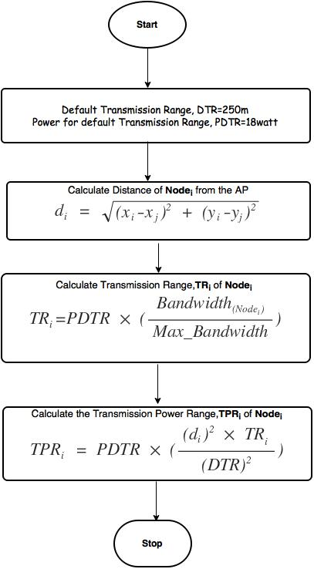

**Figure 2:** Flow chart of Variable Wi-Fi Power.

|  |  |
| --- | --- |
| **Parameters** | **Values** |
| Number of Nodes | 50 |
| Access Point | 802.11n |
| Default Transmission Range | 250m |
| Default Transmission Power | 18watt |
| Default bandwidth of nodes | 600 bytes |

**Table 1:** Experimental Setup of Variable Wi-Fi Power.

Figure 3 (a) shows the variation of aggregate energy spent in the network as the number of mobile nodes increases. *Aggregate energy* is defined as the total energy spent by all nodes if every node broadcasts one 1000-byte packet with its allocated transmission power. As the number of nodes connected to the access point increases, the aggregate energy will also increase varying from distance to distance.

# Exp1.jpg

**Figure 3 (a):** Variation of aggregate energy in a mobile Network

The Variation of energy consumption of a node with respect to distance is shown in Figure 3 (b). As the wireless node goes far from the access point the power consumption of the node also increases; but nodes nearby the access point will consume less power.

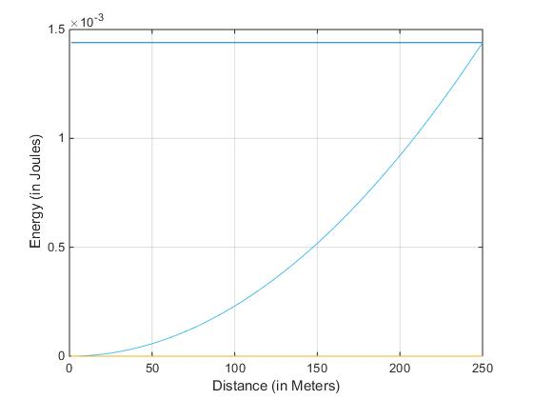

**Figure 3 (b):** Variation of Energy Consumption of a wireless node with respect to distances

# Conclusion

Assuming that Wi-Fi user are relatively static over longer time, we proposed a variable Wi-Fi power that lets mobile nodes to use variable transmission power that varies based on their position. To prove our concept, the approach has been simulated on MATLAB and the simulation results showed that up to 5% improvement in Wi-Fi power consumption compared to the existing conventional fixed transmission range schemes.

**As future Work**

* The Fixed bandwidth assumption of the nodes in the evaluation needs to be re-modelled
* Actual experiment need to be done to evaluate power efficiency and rate of disconnection

# REFERENCES

1. Mostafa Uddin, Tamer Nadeem, 2013. “A2PSM: Audio Assisted Wi-Fi Power Saving Mechanism for Smart Devices.” In *Proceedings of the 14th Workshop on Mobile Computing Systems and Applications*
2. Trevor Pering, Yuvraj Agarwal, Rajesh Gupta, Roy Want, Intel Research, 2006. “CoolSpots: Reducing the Power Consumption of Wireless Mobile Devices with Multiple Radio Interfaces.” *MobiSys2006.*
3. Arthi Kothandaraman, 2008. “An Energy-Efficient Transmission Power Control Protocol for Cooperative Robotics.” *Aurbun University 2008*
4. Agarwal, Y., Schurgers C., and Gupta R., “Dynamic Power Management using On Demand Paging for Networked Embedded Systems”, *In Proc. of Asia-South Pacific Design Automation Conference (ASPDAC), 2005*.
5. Raj Jain, “Power Management in Wireless Networks”, 2006
6. Pering, T., Raghunathan, V., and Want R., “Exploiting radio hierarchies for power-efficient wireless device discovery and connection setup”. *In Proceedings of the IEEE International Conference on VLSI Design, (January 2005).*
7. (<http://www.networkworld.com/article/2282615/network-security/beware-the-802-11n--power--play.html>